Kamil Káčer 211777

ASCII je kodovací systém znakov anglickej abecedy, číslic slúžiacich k riadeniu dátového prenosu

Obrázok časového signálu pri prenose dat ‘DE2‘

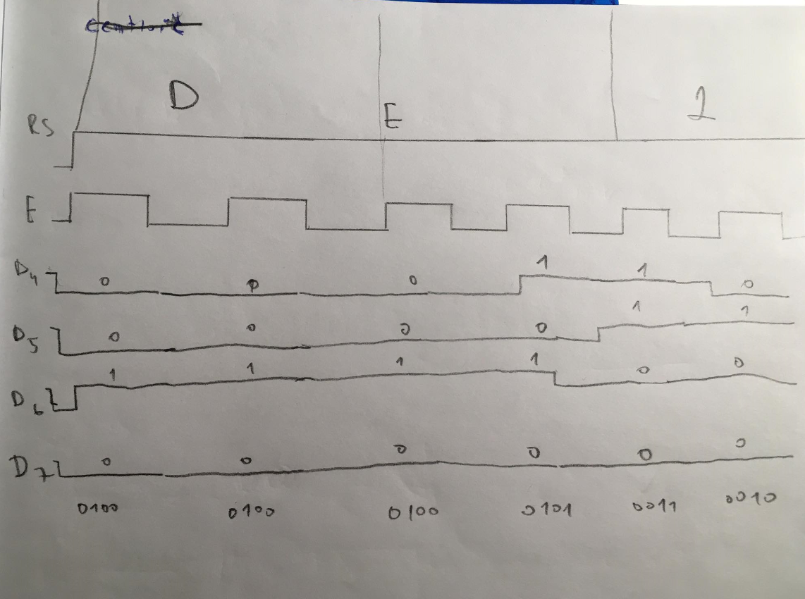

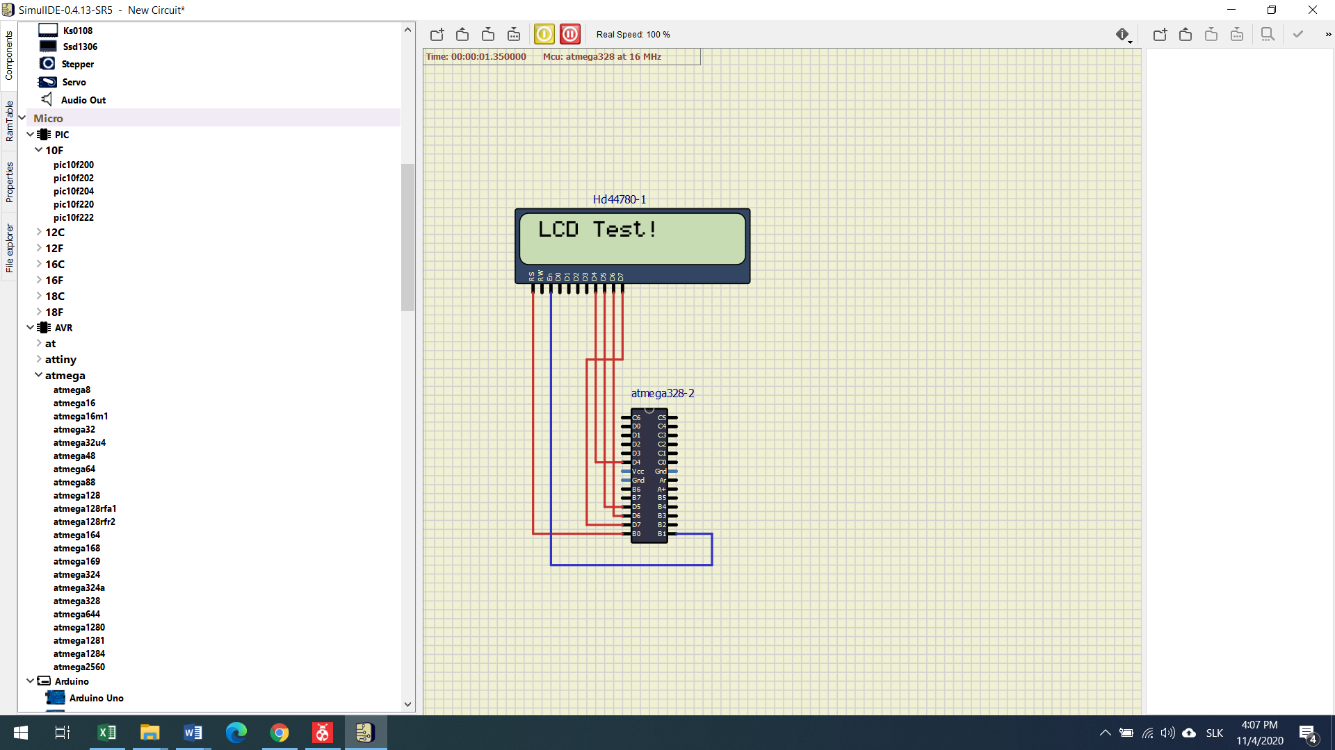

Lcd test

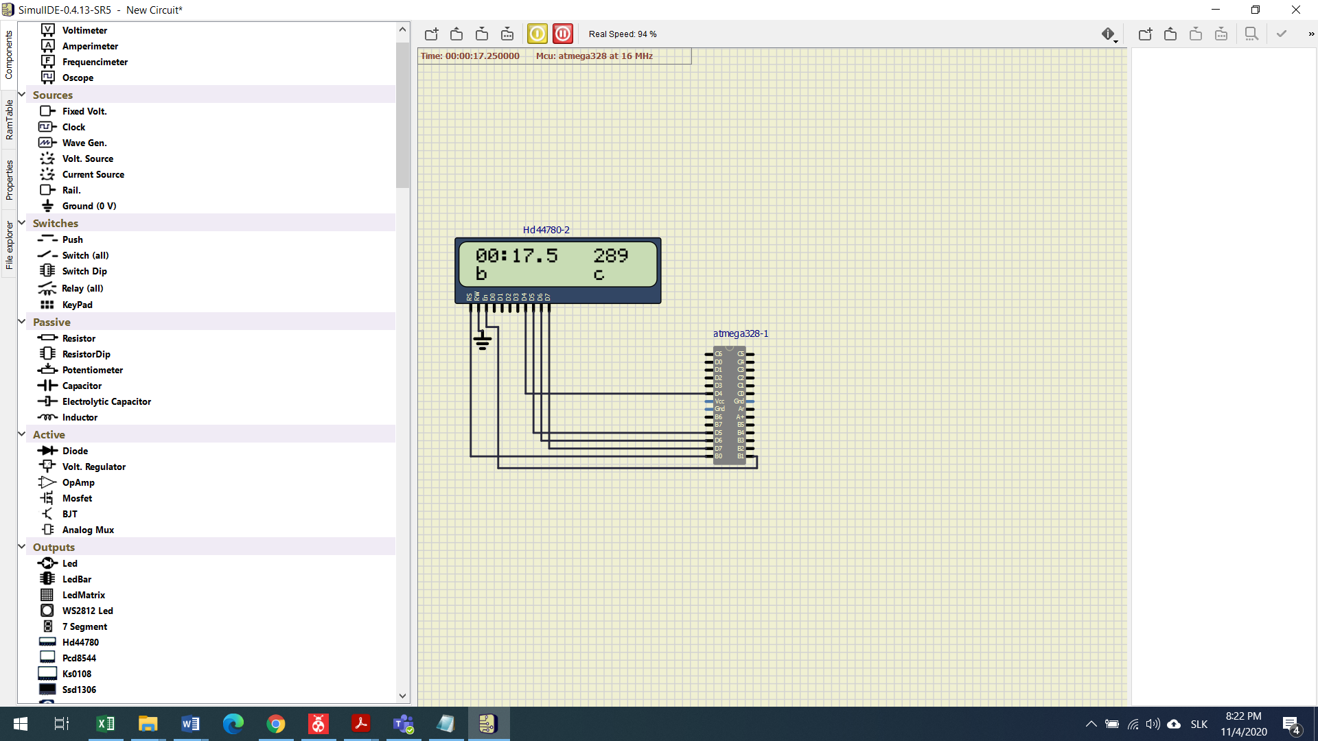

Timer with powered seconds.

Custom chararacter definition.

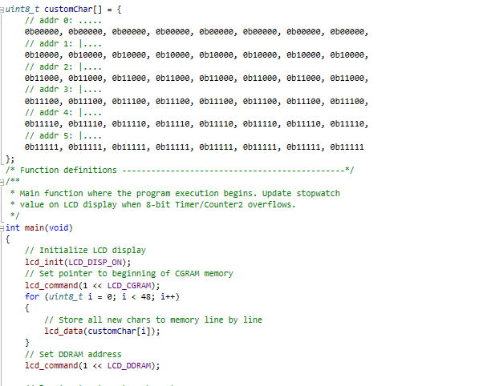

Stop watch code:

/***********************************************************************

*

* Stopwatch with LCD display output.

* ATmega328P (Arduino Uno), 16 MHz, AVR 8-bit Toolchain 3.6.2

*

* Copyright (c) 2017-2020 Tomas Fryza

* Dept. of Radio Electronics, Brno University of Technology, Czechia

* This work is licensed under the terms of the MIT license.

*

**********************************************************************/

/* Includes ----------------------------------------------------------*/

#include <avr/io.h> // AVR device-specific IO definitions

#include <avr/interrupt.h> // Interrupts standard C library for AVR-GCC

#include "timer.h" // Timer library for AVR-GCC

#include "lcd.h" // Peter Fleury's LCD library

#include <stdlib.h> // C library. Needed for conversion function

/* Function definitions ----------------------------------------------*/

/**

* Main function where the program execution begins. Update stopwatch

* value on LCD display when 8-bit Timer/Counter2 overflows.

*/

int main(void)

{

// Initialize LCD display

lcd_init(LCD_DISP_ON);

// Put string(s) at LCD display

lcd_gotoxy(1, 0);

lcd_puts("00:00.0");

lcd_gotoxy(11, 0);

lcd_putc('a');

lcd_gotoxy(1, 1);

lcd_putc('b');

lcd_gotoxy(11, 1);

lcd_putc('c');

// Configure 8-bit Timer/Counter2 for Stopwatch

// Set prescaler and enable overflow interrupt every 16 ms

TIM2_overflow_16ms();

TIM2_overflow_interrupt_enable()

// Enables interrupts by setting the global interrupt mask

sei();

// Infinite loop

while (1)

{

/* Empty loop. All subsequent operations are performed exclusively

* inside interrupt service routines ISRs */

}

// Will never reach this

return 0;

}

/* Interrupt service routines ----------------------------------------*/

/**

* ISR starts when Timer/Counter2 overflows. Update the stopwatch on

* LCD display every sixth overflow, ie approximately every 100 ms

* (6 x 16 ms = 100 ms).

*/

ISR(TIMER2_OVF_vect)

{

static *uint8_t* number_of_overflows = 0;

static *uint8_t* tens = 0;

static *uint8_t* secs = 0;

static *uint8_t* min = 0;

*uint16_t* squaresecs = secs * secs;

//static uint8_t secs_1 = 0;

char lcd_string[2] = " "; //string for converting numbers

number_of_overflows++;

if (number_of_overflows >= 6)

{

// Do this every 6 x 16 ms = 100 ms

number_of_overflows = 0;

tens ++;

if (tens > 9)

{

tens = 0;

secs ++;

}

*itoa*(tens, lcd_string, 10);

lcd_gotoxy(7, 0);

lcd_puts(lcd_string);

if (secs > 59)

{

secs = 0;

min ++;

lcd_gotoxy(4, 0);

lcd_putc('0');

}

*itoa*(secs, lcd_string, 10);

if (secs > 9)

{

lcd_gotoxy(4,0);

}

else

{

lcd_gotoxy(5,0);

}

lcd_puts(lcd_string);

if (min > 60)

{

min = 0;

lcd_putc('0');

lcd_gotoxy(2, 0);

}

*itoa*(min, lcd_string, 10);

if (min > 9)

{

lcd_gotoxy(1,0);

}

else

{

lcd_gotoxy(2,0);

}

lcd_puts(lcd_string);

*itoa*(squaresecs, lcd_string, 10);

if (squaresecs = 0)

{

lcd_gotoxy(11, 0);

lcd_puts("0 ");

}

else

{

lcd_gotoxy(11,0);

}

lcd_puts(lcd_string);

}

}

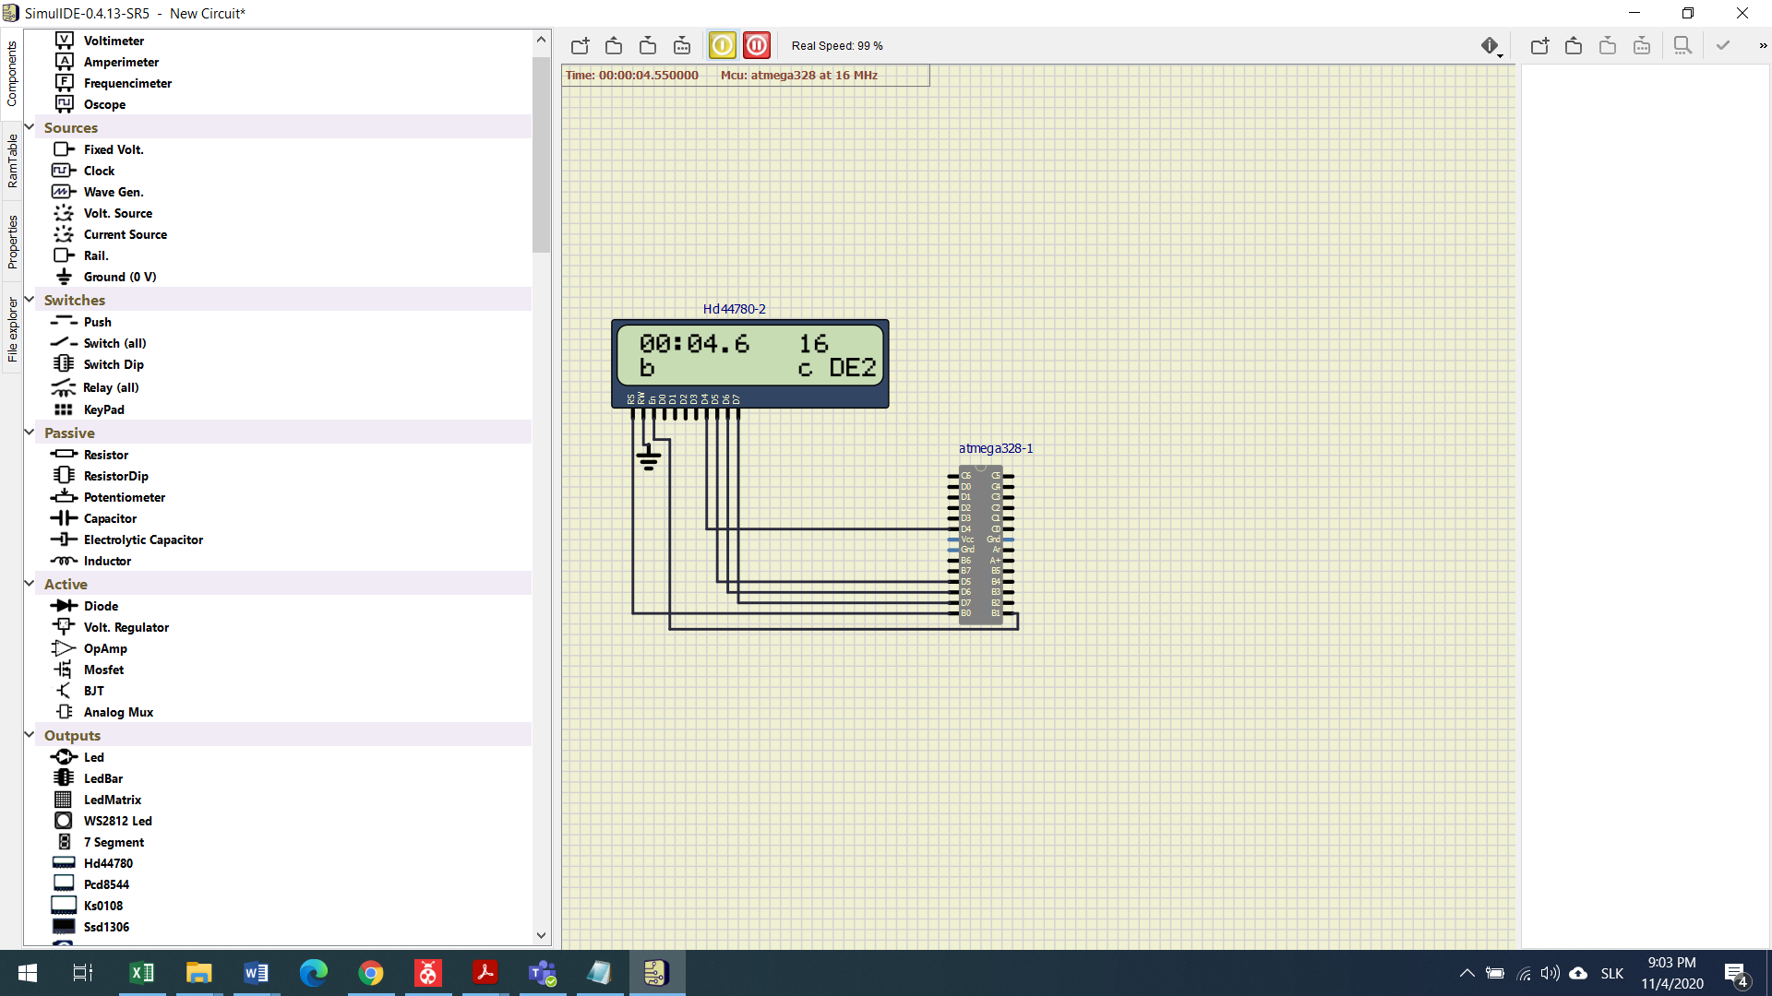





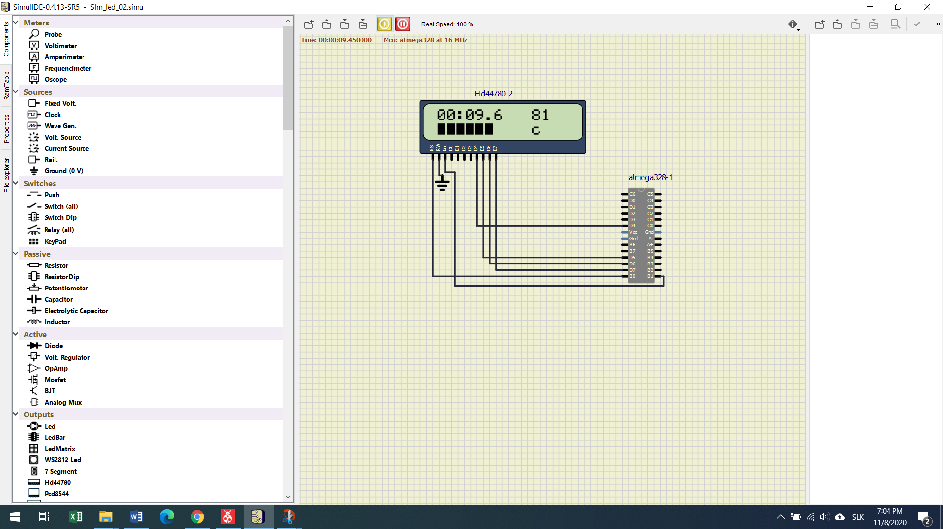

**Loading bar**

ISR(TIMER0_OVF_vect)

{

static *uint8_t* symbol = 0;

static *uint8_t* position = 0;

static *uint8_t* ovrflov = 0;

ovrflov ++;

if(ovrflov >= 1)

ovrflov = 0;

lcd_gotoxy(1 + position, 1);

lcd_putc(symbol);

symbol ++;

if(symbol > 5)

{

position ++;

symbol = 0;

if(position == 9)

{

position = 0;

lcd_gotoxy(9,1);

lcd_putc(0);

lcd_gotoxy(8,1);

lcd_putc(0);

lcd_gotoxy(7,1);

lcd_putc(0);

lcd_gotoxy(6,1);

lcd_putc(0);

lcd_gotoxy(5,1);

lcd_putc(0);

lcd_gotoxy(4,1);

lcd_putc(0);

lcd_gotoxy(3,1);

lcd_putc(0);

lcd_gotoxy(2,1);

lcd_putc(0);

lcd_gotoxy(1,1);

lcd_putc(0);

}

}

}